**Microprocessor and Computer Architecture**

**UE20CS252**

**4th Semester, Academic Year 2021-22**

Date: 31/01/2022

|  |  |  |
| --- | --- | --- |
| Name: Vishwa Mehul Mehta | SRN: PES2UG20CS389 | Section:  F |

Week#3 Program Number: 1

Title of the Program

**Write a program in ARM7TDMI-ISA to find the sum of N data items in the memory. Store the result in the memory location.**

**a. Use Full word (.word directive)**

1. ARM Assembly Code:

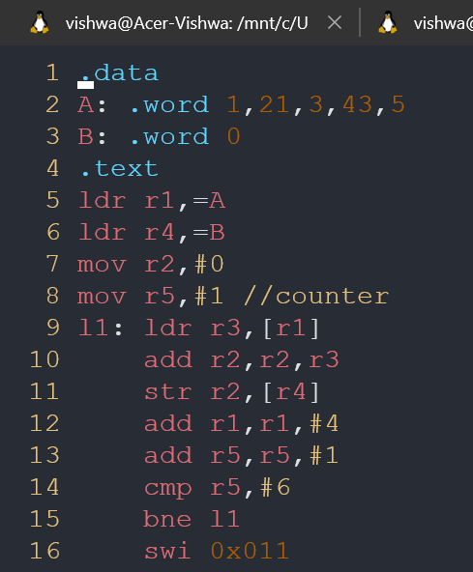

1. Output Screen Shot:

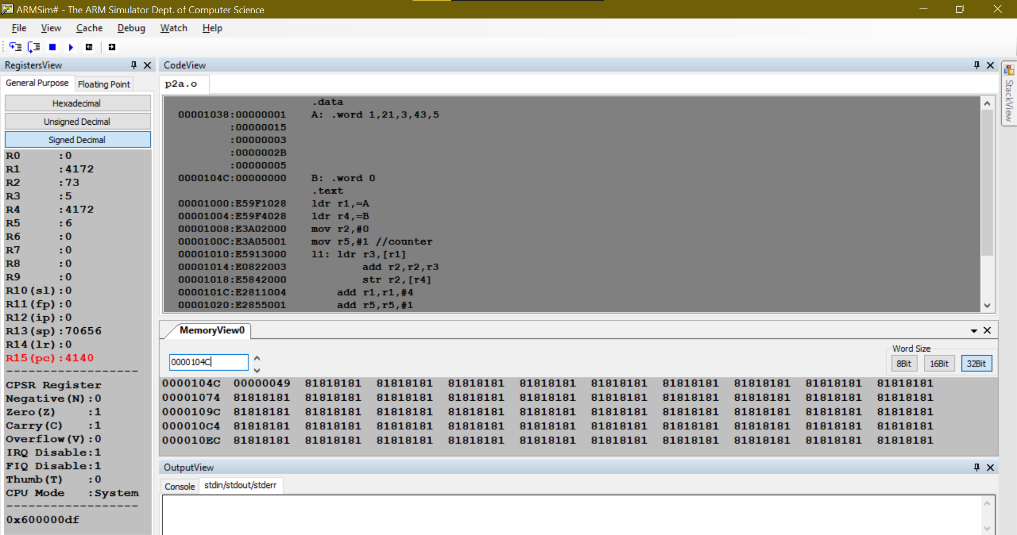

**b. Use Half word(.Hword directive)**

1. ARM Assembly Code:

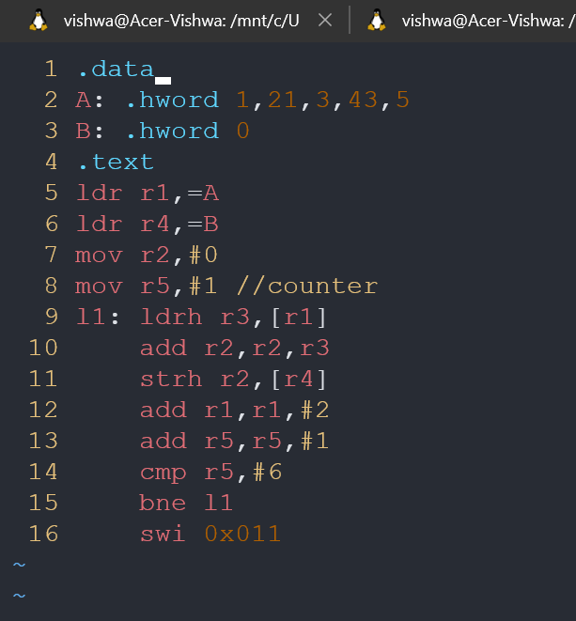

1. Output Screen Shot:

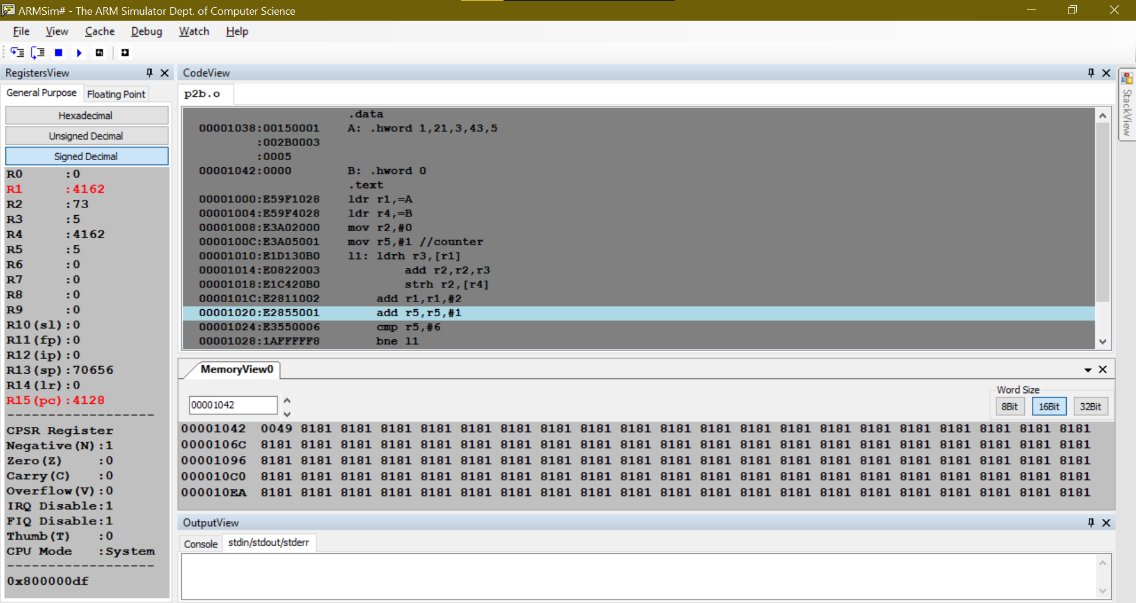

**c. Use Byte wise (.Byte directive)**

1. ARM Assembly Code:

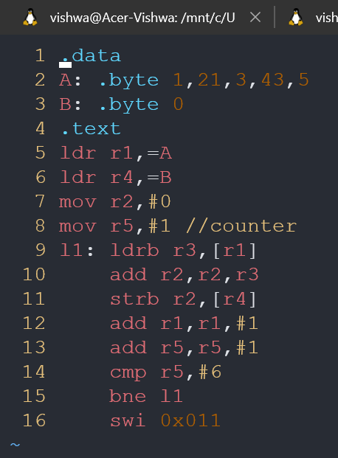

1. Output Screen Shot:

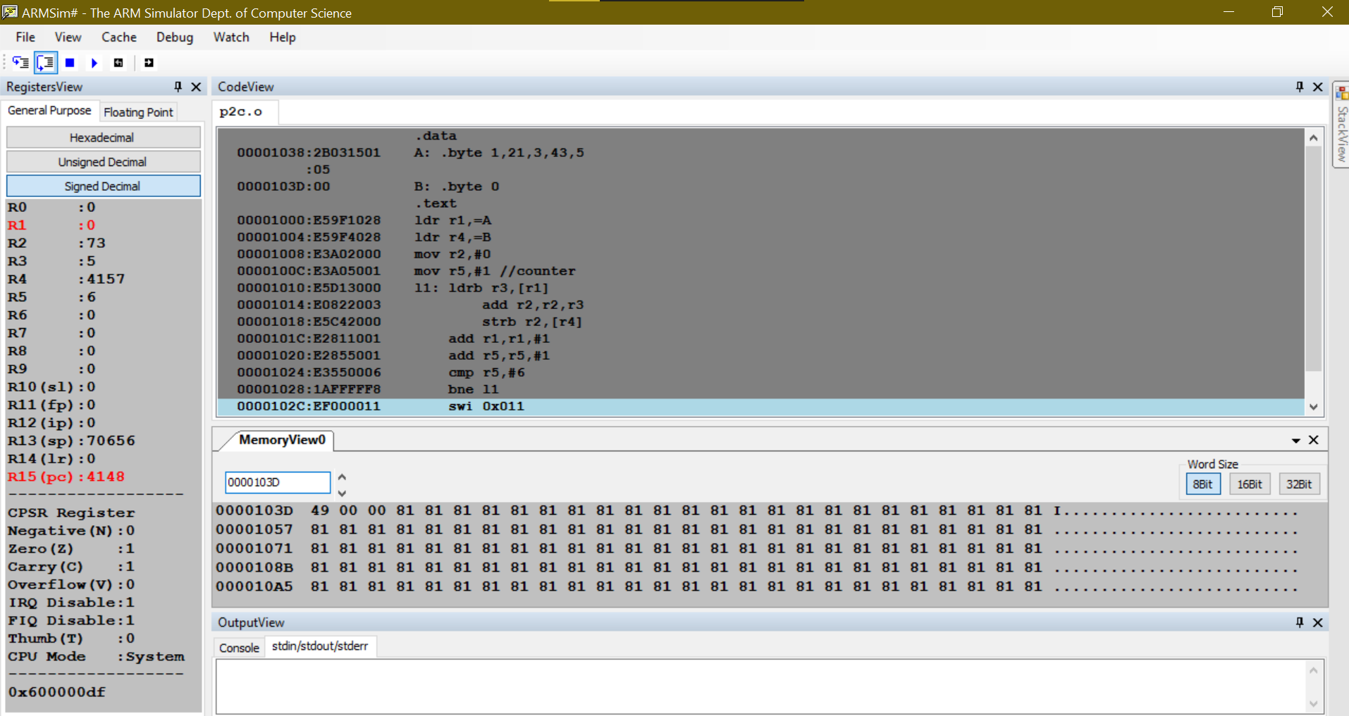

**Microprocessor and Computer Architecture**

**UE20CS252**

**4th Semester, Academic Year 2021-22**

Date: 31/01/2022

|  |  |  |
| --- | --- | --- |
| Name: Vishwa Mehul Mehta | SRN: PES2UG20CS389 | Section:  F |

Week#3 Program Number: 2

Title of the Program

**Write a program in ARM7TDMI-ISA to find the sum of N natural numbers. Store the result in the memory location.**

1. ARM Assembly Code:

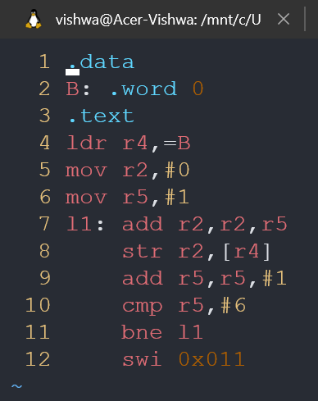

1. Output Screen Shot:

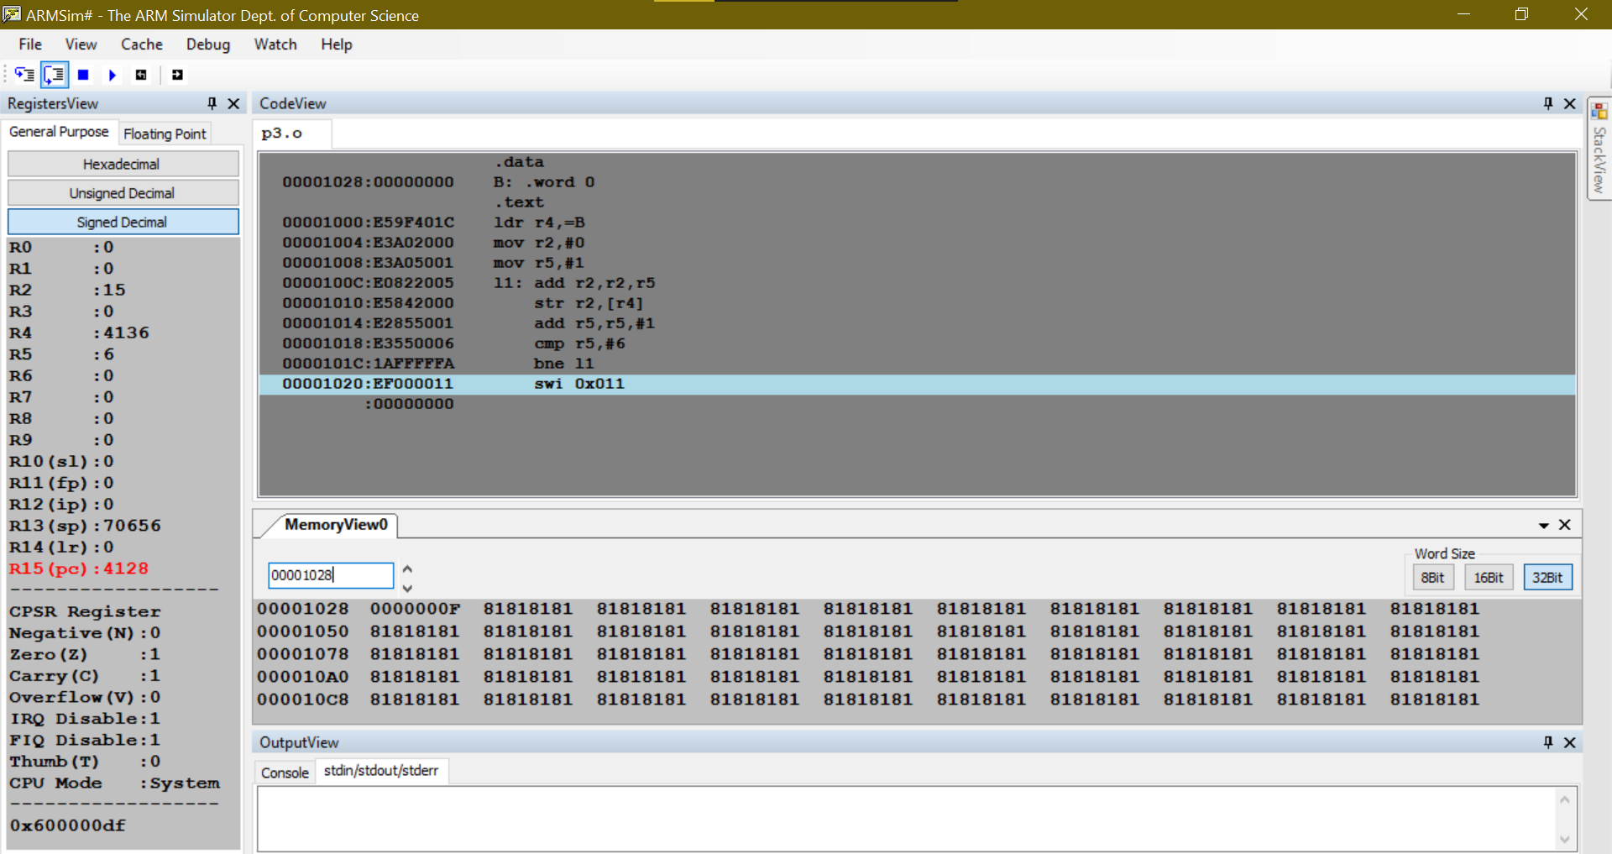

**Microprocessor and Computer Architecture**

**UE20CS252**

**4th Semester, Academic Year 2021-22**

Date: 31/01/2022

|  |  |  |
| --- | --- | --- |
| Name: Vishwa Mehul Mehta | SRN: PES2UG20CS389 | Section:  F |

Week#3 Program Number: 3

Title of the Program

**Convert the following statement in C language into an ALP using ARM7TDMI – ISA.**

**IF([A]==[B]) then C=[A]+[B];**

**ELSE IF ([B]==[C]) D=[A]-[B];**

**ELSE E=[A]*[B]**

**Where A,B C, D & E are memory locations.**

1. ARM Assembly Code:

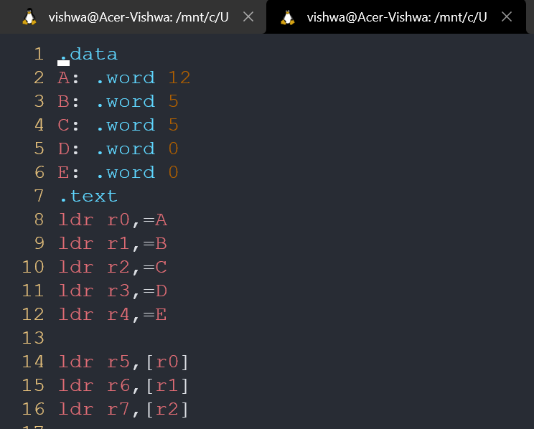

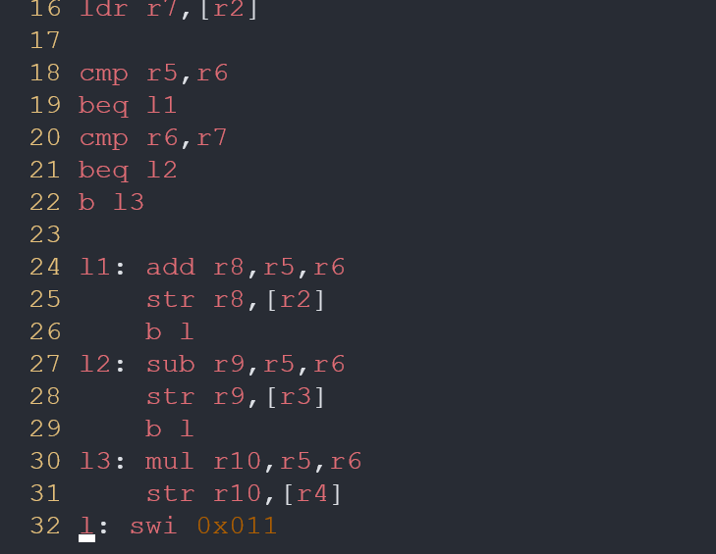

1. Output Screen Shot:

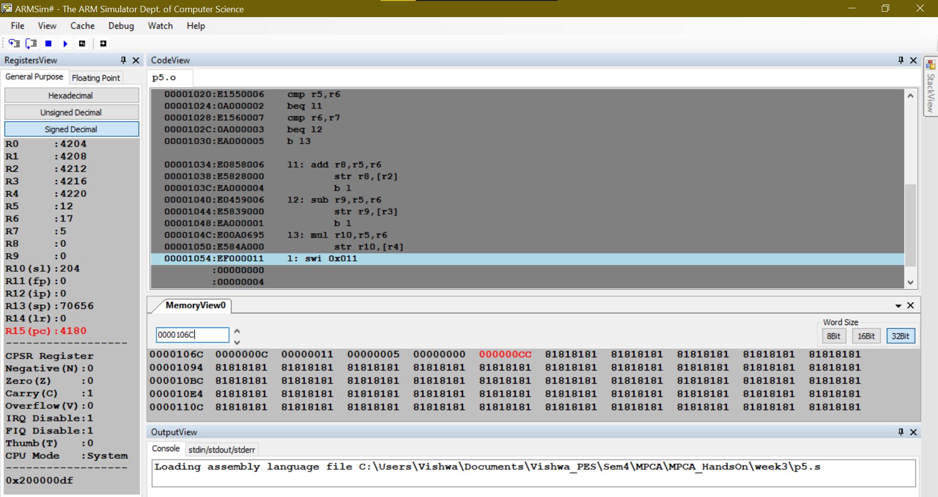

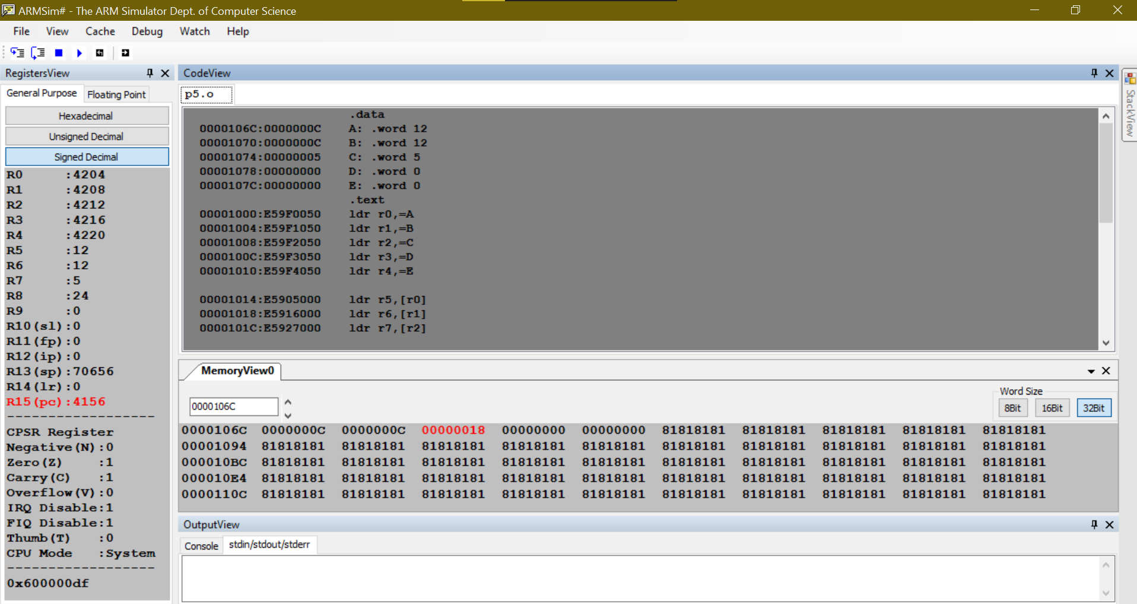

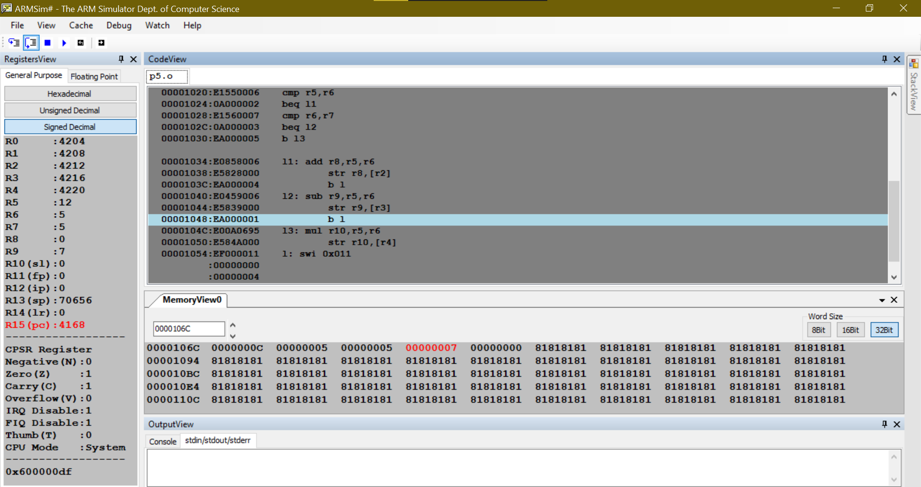

**Disclaimer:**

* The programs and output submitted is duly written, verified and executed by me.
* I have not copied from any of my peers nor from the external resource such as internet.
* If found plagiarized, I will abide with the disciplinary action of the University.

Signature: Vishwa Mehul Mehta

Name: Vishwa Mehul Mehta

SRN: PES2UG20CS389

Section: F

Date: 31/01/2022